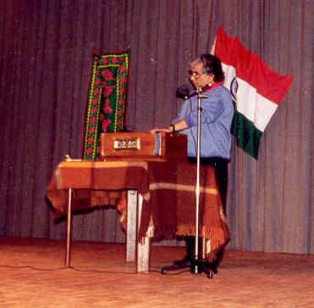

Dr Srikanta Bandyopadhyay of Sydney singing his own Hindi
Compositions in Zurich Switzerland on
15 Aug 1997

