**ASOKE KUMAR DEYSARKAR**

**Bachelor of Technology (Honours),** 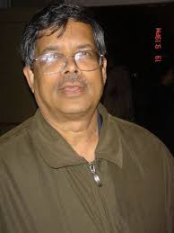

**Chemical Engineering, 1971**

Class topper of his batch at IIT Kharagpur, Asoke K. Deysarkar is a successful entrepreneur, hailed for his leadership prowess as well as his technical expertise, especially in the areas of Hydraulic Fracturing, Fluid Rheology, Refining and Consumer Products. He completed his Masters degree and Ph.D. (1976) in Chemical Engineering from the University of Greater Manchester (Salford) in UK. He also has an MBA from the University of Houston and has worked as a researcher at the University of Waterloo.

Dr. Deysarkar started his career in industry as Senior Project Engineer at Dresser Industries and thereafter served at Pennzoil as Product Manager. In 2002, he started his own company called "Products for People" in Houston, which formulated products for the automotive after-market. He also developed another line of products based on GUAR - a product used as a thickener for water in fracturing of oil/gas wells. The business is now run under the umbrella of PfP Industries, headquartered in Houston, Texas (USA) with branches in various locations around the United States. Dr. Deysarkar is currently CEO and Chairman of the group.

Not only has Dr. Deysarkar built a successful $1.5-billion conglomerate from scratch in the oil and gas sector, he has also adopted a vision of creating a new crop of professionals who will be game changers in that industry. Teaming up with his wife Ruma Acharya Deysarkar, he has donated $1 million to IIT Kharagpur towards establishing a one-of-its- kind programme in the country-the Trans-Disciplinary Programme in Petroleum Engineering.

Dr. Deysarkar is also a committed patron of the arts and culture in Houston, where a statue of Rabindranath Tagore was erected in the city through the family's largesse. In 2015, he and his wife were the principal sponsors of the North American Bengali Conference in Houston.

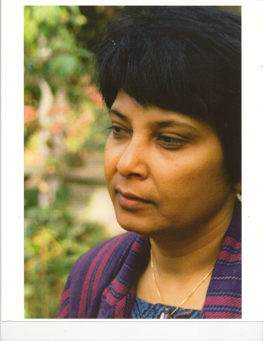**RUMA ACHARYA**

**Master of Technology, 1973**

**Chemical Engineering**

Dr. Ruma Acharya is an entrepreneur, researcher, philanthropist and an exemplary leader in community service.

Dr. Acharya completed her M. Tech. in Chemical Engineering from IIT Kharagpur in 1973. She obtained her Ph. D. from University of Salford of Greater Manchester specializing in Rheology and Fluid Mechanics. She also completed her MBA from the University of Houston. She did her post-doctoral work at the Northwestern University with Professor John Slattery where she helped him develop a pioneering device to measure interfacial viscosity and interfacial tension of polymeric fluids.

Dr. Acharya worked on fundamental research of fluid mechanics (Rheology) of polymeric fluids. Her work was the first to identify and recognize the wake phenomena in viscoelastic fluids that is primarily responsible for the drag /friction reduction in fluid flow. Her technical publications are the pioneering work of polymer rheology that has often been referred by the fracturing industries of oil field services.

After working for 15 years in the oil industry in the areas of reservoir and production engineering, she started her own engineering consulting company, Ground Technology, Inc. (GTI) specializing in environmental, civil engineering and construction management. She sold GTI in 2010 and founded Scindia LLC which specializes primarily in planning, design and construction management.

Dr. Acharya continues to support in multiple ways the Centre of Excellence in Petroleum Engineering at this Institute, which was founded with financial support from her and her family. She has initiated a scholarship program for women with the Institute of Chemical Engineers India to encourage women to study Chemical Engineering. In her personal life Dr. Acharya is a dedicated volunteer and a driven leader in her community. She is working on her latest philanthropic work - to build a multi-usage cultural facility Tagore Center for Visual & Performing Arts in Houston, TX. While serving as the President of the Tagore society of Houston, Texas, Dr. Acharya took the initiative to erect a life size bronze statue of Rabindranath Tagore and created Tagore Grove in Houston, first of its kind in North America.