Soumen Chakrabarti
Bachelor of Technology (Honours), 1991
Computer Science and Engineering

Prof. SoumenChakrabarti is a renowned academician and researcher who was honoured with the Shanti SwarupBhatnagar award in 2014. Currently, he is a professor in the Department of Computer Science and Engineering, IIT Bombay. Prof. Chakrabarti’s bookMining the Web: Discovering Knowledge from Hypertext Data (2002) is a seminal graduate-level text on statistical modeling and analysis of hypertext with emphasis on search technology.

Prof.Chakrabarti did his B. Tech. in Computer Science and Engineering from IIT Kharagpur and received the President of India Gold Medal in 1991. He secured the third rank in IIT JEE. He earned his M.S. and Ph.D. in Computer Science from the University of California, Berkeley in 1992 and 1996, respectively. In 1999, he joined IIT Bombay and became an Associate Professor in 2003. In Spring 2004, he was a visiting professor at Carnegie-Mellon University. During 2014-2016, he was a Visiting Scientist at Google.He was a Research Staff Member at IBM Almaden Research Center from 1996 to 1999, where he was part of the prestigious CLEVER project that has an essential role to play in the core ranking algorithm (PageRank) of Google. He is also a fellow of INAE, IAS, and INSA.

Prof.Chakrabarti’s research passion is focusedon crawlers, and search algorithm on graph databases that has a tremendous influence on modern web algorithms like Facebook graph search algorithm. His model of close industry-academia interaction has been a great inspiration to an entire generation of Indian researchers in developing the Indian AI-Web research community. His current research interests include integrating, searching, and mining text and graph data models, exploiting types, and relations in search and continuous representations of words, entities, types and relations.
Prof. Chakrabartiwon the best paper award at WWW in 1999. He co-authored the best student paper at ECML in 2008. His work on keyword search in databases got the 10-year influential paper award at ICDE in 2012.He was also bequeathed withAmazon Research Award (2019), H. H. Mathur Award (2013) and Google Faculty Research Awards (2013, 2011).
Prof. Chakrabarti has served as a technical advisor to search companies;as a vice-chair or program committee member for WWW 2010, WSDM 2008, SIGIR, SIGKDD, VLDB, ICDE, SODA and other conferences, and as a guest editor or editorial board member for Foundations and Trends in Information Retrieval, DMKD and TKDE journals. He has published more than 68 papers in journals and conferences international of international repute. He holds 11 US patents on Web-related inventions.

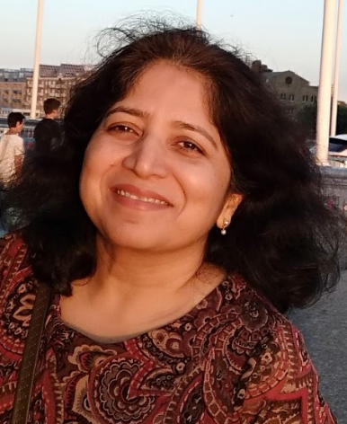
Sunita Sarawagi
Bachelor of Technology (Honours), 1991
Computer Science and Engineering

Prof. Sunita Sarawagi is acknowledgedas an adept researcher in the area of databases, data mining and machine learning; she is one of the highly cited researchers in India. She is currentlythe Chair of the Department of Computer Science, IIT Bombay, and a member of the IEEE John Von Neumann Medal committee. Her current research interests are domain adaptation, structured and sequence prediction models, deep learning, graphical models, and information extraction.

Prof. Sarawagiaccomplished her B.Tech. degree in Computer Science and Engineering from IIT Kharagpur in 1991. She was awarded the Institute award for the second highest GPA, and the best undergraduate thesis award. She received her M.S. and Ph.D. in Computer Science from the University of California, Berkeley in 1993 and 1996 respectively.

At the IBM Almaden Research Center, Prof. Sarawagi worked on algorithms for OLAP and Data Mining, as a Research Staff Member; a part of this work was transferred to IBM's Intelligent Miner product. In 2004, she was a visiting faculty at CMU Pittsburgh, where she co-developed the Semi Markov Conditional Random Field (Semi-CRF) model with William Cohen. Prof. Sarawagi has spent her two years as a visiting faculty at Google Research. She has also worked on deep learning models for personalizing and diversifying YouTube and Play recommendations, for improving a conversation assistance engine, and for extracting attributes of classes from the Knowledge Graph.
Prof. Sarawagi has several publications in machine learning, NLP, databases and data mining. Her monogram on Information Extraction is widely read and cited. On Google scholar she has 11700 citations and an h-index of 44. She holds seven US patents in relation to her work at IBM Almaden and Microsoft Research. Her software on automatic segmentation of Indian addresses was licensed by a data cleaning company in 2001.

Prof. Sarawagiwas an active part of the board of directors of ACM SIGKDD and VLDB foundation. She was the program chair for the ACM SIGKDD 2008 conference, the research track co-chair for the VLDB 2011 conference and was also a program committee member for SIGMOD, VLDB, SIGKDD, ICDE, and ICML conferences.
Prof. Sarawagi is a fellow at the Indian National Academy of Engineering (INAE). She was awarded the best paper award in the ACM SIGMOD conference in 1998, the ACM SIGKDD service award in 2009, honorary outstanding student paper award in NIPS 2010, runners-up best paper at the IEEE ICDM conference 2012, and the PAKDD most influential ten-year award in 2014.

