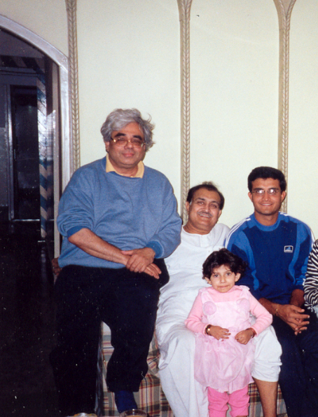
Around early 2000, Bandy the singing professor (Srikanto Bandyopadhyay of Sydney) with Sourav Ganguly’s father Mr Chandi Ganguly, and Mr Sourav Ganguly – in Behala, Home of Sourav Ganguly

