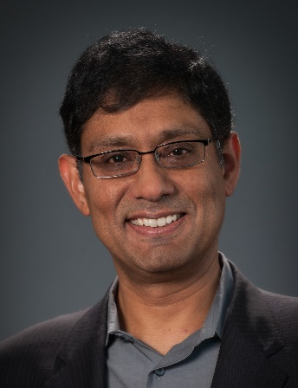

Prith Banerjee is the Chief Technology Officer of ANSYS where he is responsible for leading the evolution of ANSYS’ Technology strategy and champion the company’s next phase of innovation and growth. He also serves on the Board of Directors of Cray, Inc., Cubic Corporation and Software Motor Corporation.

Previously he was the Senior Client Partner at Korn Ferry where he was responsible for IOT and Digital Transformation in the Global Industrial Practice. Formerly, he was Executive Vice President, Chief Technology Officer of Schneider Electric. Previously, he was Managing Director of Global Technology Research and Development at Accenture. Formerly, he was Chief Technology Officer and Executive Vice President of ABB. Earlier, he was Senior Vice President of Research at HP and Director of HP Labs.

Formerly, he was Dean of the College of Engineering at the University of Illinois at Chicago. Formerly, he was the Walter P. Murphy Professor and Chairman of Electrical and Computer Engineering at Northwestern University. Prior to that, he was Professor of Electrical and Computer Engineering at the University of Illinois at Urbana-Champaign.

In 2000, he founded AccelChip, a developer of products for electronic design automation, which was acquired by Xilinx Inc. in 2006. During 2005-2011, he was Founder, Chairman and Chief Scientist of BINACHIP Inc., a developer of products in electronic design automation.

He is the author of more than 350 publications in journals and conferences, one book and several book chapters. He has advised more than 35 Ph.D. students and 40 M.S. students during his academic career. He was listed in the FastCompany list of 100 top business leaders in 2009. He is a Fellow of the AAAS, ACM and IEEE, and a recipient of the 1996 ASEE Terman Award, the IEEE Taylor Booth Award, and the 1987 NSF Presidential Young Investigator Award.

He received a B.Tech. in electronics engineering from the Indian Institute of Technology, Kharagpur (President’s Gold Medal) in 1981, and an M.S. and Ph.D. in electrical engineering from the University of Illinois, Urbana in 1982 and 1984.

